Apply Regularization & Dimension Reduction Methods using Auto Data

QUESTION:10

In this exercise, we will predict the number of applications received using the other variables in the College data set.

(a) Split the data set into a training set and a test set.
Code:
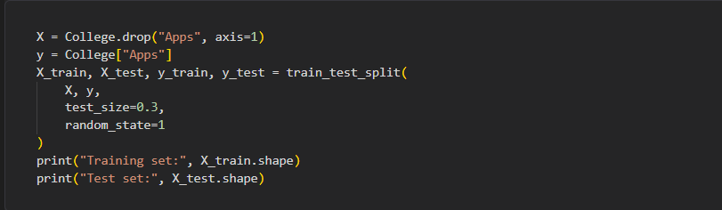
Output:
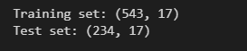
Interpretation:
The dataset was split into 543 training observations and 234 test observations, with 17 predictor variables used to predict the number of college applications.

(b) Fit a linear model using least squares on the training set, and report the test error obtained.
Code:
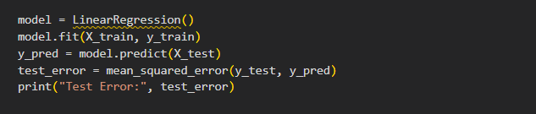
Output:

Interpretation:
The linear regression model achieved a test mean squared error of 642,753.90, indicating the average squared difference between the actual and predicted application numbers.
(c) Fit a ridge regression model on the training set, with λ chosen by cross-validation. Report the test error obtained.
Code:
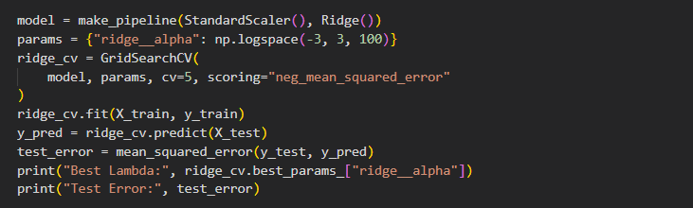
Output:
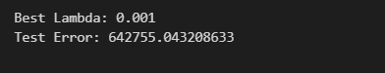
Interpretation:
The ridge regression model selected the best lambda (λ) as 0.001 through cross-validation and achieved a test error of 642,755.04, which is nearly identical to the linear regression model.

(d) Fit a lasso model on the training set, with λ chosen by cross-validation. Report the test error obtained, along with the number of non-zero coefficient estimates.

Code:
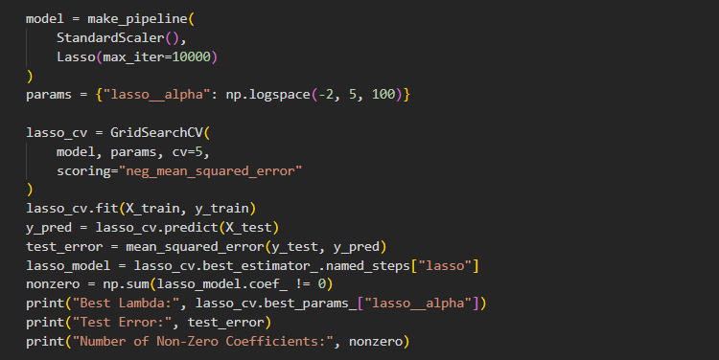

Output:
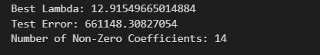

Interpretation:
The lasso model selected λ = 12.9155 and achieved a test error of 661,148.31, retaining 14 non-zero coefficients and setting the remaining coefficients to zero.

(e) Fit a PCR model on the training set, with M chosen by cross-validation. Report the test error obtained, along with the value of M selected by cross-validation.

Code:
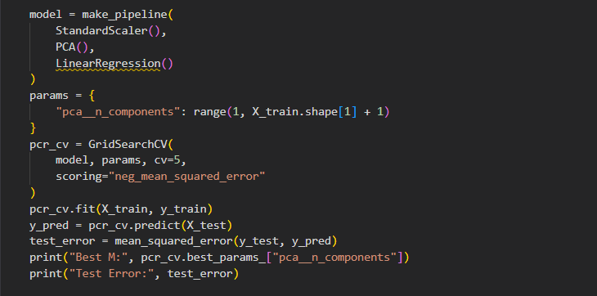

Output:
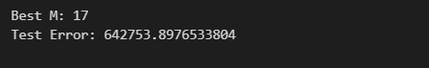
Interpretation:
The PCR model selected 17 principal components (M = 17) through cross-validation and achieved a test error of 642,753.90, similar to the linear regression model.

(f) Fit a PLS model on the training set, with M chosen by cross-validation. Report the test error obtained, along with the value of M selected by cross-validation.
Code:
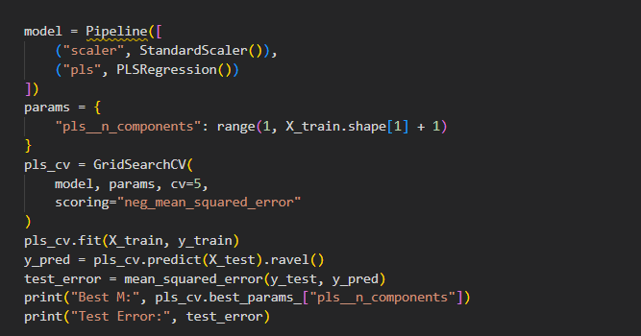
Output:
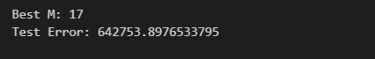
Interpretation:
The PLS model selected 17 components (M = 17) through cross-validation and achieved a test error of 642,753.90, similar to the linear regression, PCR, and ridge regression models.

(g) Comment on the results obtained. How accurately can we pre-dict the number of college applications received? Is there much difference among the test errors resulting from these five approaches?

Code:
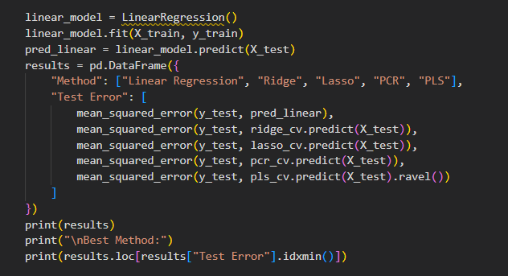

Output:
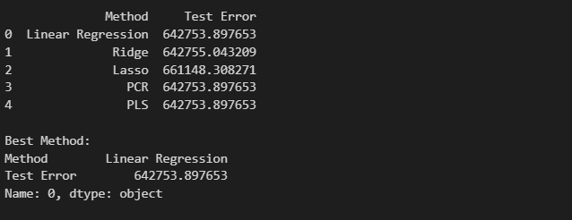
Interpretation:
All five methods have similar test errors, with linear regression performing best at 642,753.90. Overall, the models show similar predictive accuracy, with no significant difference in their performance.

